2.3 a. Stem-and-Leaf Display of Profit Margin n = 35
Leaf Unit = 0.10
 | Frequency |  | Stem
 | 2 |  | 1| | 1 8
 | 2 |  | 2| | 2 9
 | 6 |  | 3| | 1 2 3 6 6 9
 | 4 |  | 4| | 0 4 7 9
 | 12 |  | 5| | 0 0 0 2 3 4 8 9 9 9 9 9
 | 3 |  | 6| | 1 8 9
 | 1 |  | 7| | 0
 | 1 |  | 8| | 6
 | 1 |  | 9| | 2
 | 1 |  | 10| | 9
 | 1 |  | 11| | 2
 |  |  | 12|
 |  |  | 13|
 |  |  | 14|
 |  |  | 15|
 |  |  | 16|
 |  |  | 17|
 |  |  | 18|
 |  |  | 19|
 |  |  | 20|
 |  |  | 21|
 |  |  | 22|
 |  |  | 23|
 | 1 |  | 24| | 0

Distribution is skewed to the right.

b. Stem-and-Leaf of Display on Capital n = 35
Leaf Unit = 0.10
 | Frequency |  | Stem
 | 1 |  | 0| | 0
 |  |  | 1|
 |  |  | 2|
 |  |  | 3|
 | 1 |  | 4| | 0
 |  |  | 5|
 |  |  | 6|
 |  |  | 7|
 | 2 |  | 8| | 3 6
 | 1 |  | 9| | 2
 |  |  | 10|
 | 4 |  | 11| | 0 2 5 6
 | 3 |  | 12| | 6 7 8
 | 1 |  | 13| | 1
 | 3 |  | 14| | 4 7 7
 | 3 |  | 15| | 2 4 9
 | 1 |  | 16| | 5
 | 2 |  | 17| | 0 6
 | 1 |  | 18| | 3
 | 3 |  | 19| | 2 7 8
 | 3 |  | 20| | 3 6 8
 | 2 |  | 21| | 1 7
 | 1 |  | 22| | 8
 |  |  | 23|
 |  |  | 24|
 | 2 |  | 25| | 1 7
 |  |  | 26|
 |  |  | 27|
 |  |  | 28|
 |  |  | 29|
 |  |  | 30|
 |  |  | 31|
 |  |  | 32|
 | 1 |  | 33| | 4

Distribution is quite variable, but symmetric with both high and low outliers.

c. Profit margins are skewed to the right and less spread out when compared to Return on Capital.
d. k=6
Class length=(24-1.1)/6=3.81 round up to 3.9
To form the first class, start with the smallest value 1.1.
Up limit of the first chass is 1.1+3.9-0.1=4.9
Class Frequency Boundaries
1.1 to 4.9 14 1.05, 4.95
5.0 to 8.8 17 4.95, 8.85
8.9 to 12.7 3 8.85, 12.75
12.8 to 16.6 0 12.75, 16.65
16.7 to 20.5 0 16.65, 20.55
20.6 to 24.4 1 20.55, 24.45

 |  | Profit |  |  |  |  |  | cumulative
 | lower |  | upper | midpoint | width | frequency | percent | frequency | percent
 | 1.05 | < | 4.95 | 3.00 | 3.90 | 14 | 40.0 | 14 | 40.0
 | 4.95 | < | 8.85 | 6.90 | 3.90 | 17 | 48.6 | 31 | 88.6
 | 8.85 | < | 12.75 | 10.80 | 3.90 | 3 | 8.6 | 34 | 97.1
 | 12.75 | < | 16.65 | 14.70 | 3.90 | 0 | 0.0 | 34 | 97.1
 | 16.65 | < | 20.55 | 18.60 | 3.90 | 0 | 0.0 | 34 | 97.1
 | 20.55 | < | 24.45 | 22.50 | 3.90 | 1 | 2.9 | 35 | 100.0
 | 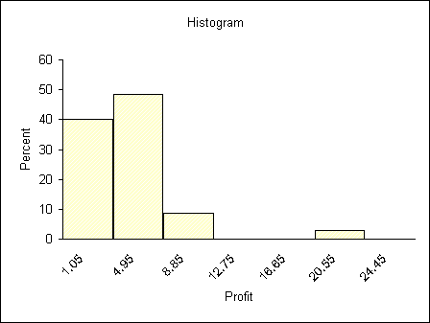
2.15 N MEAN MEDIAN MODE
a 10 9.600 10.000 10.00
b 9 103.33 100.00 90.00

2.18
a. Yes, because and the sample mean is the point estimate of the population mean.
b.
The mean is slightly larger than the median. The stem-and-leaf display is somewhat skewed to the right.

2.36
Solution to a
= 276.7

Also

Solution to b

Solution to c
Yes, because $190 is not within the 99.73% interval.
Solution to d
z₁₅₇= 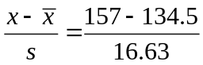 = 1.353
z₁₃₂ = –0.150
z₁₀₉ = –1.533
z₁₄₅ = 0.631
z₁₂₅ = –0.571
z₁₃₉ = 0.271

2.38
(a)

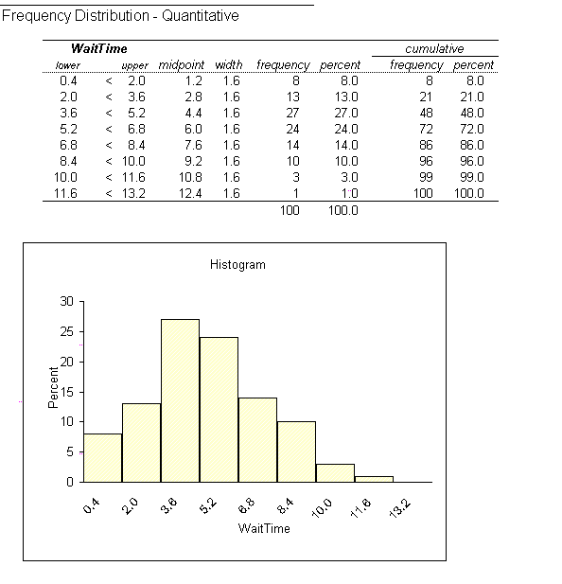

The Empirical Rule should be used. Because the Rule not only holds for normally distributed populations, but also approximately holds for populations having mound-shaped distributions that are not very skewed to the right or left.
Solution to b

Solution to c
Yes, because the upper limit of the 68.26% interval is less than 8 minutes.
Solution to d
66% fall into 96% fall into , 100% fall into .
Yes, they are reasonably valid. Although there are some differences when it comes to b, c, it is approximately same.

2.46
(a)
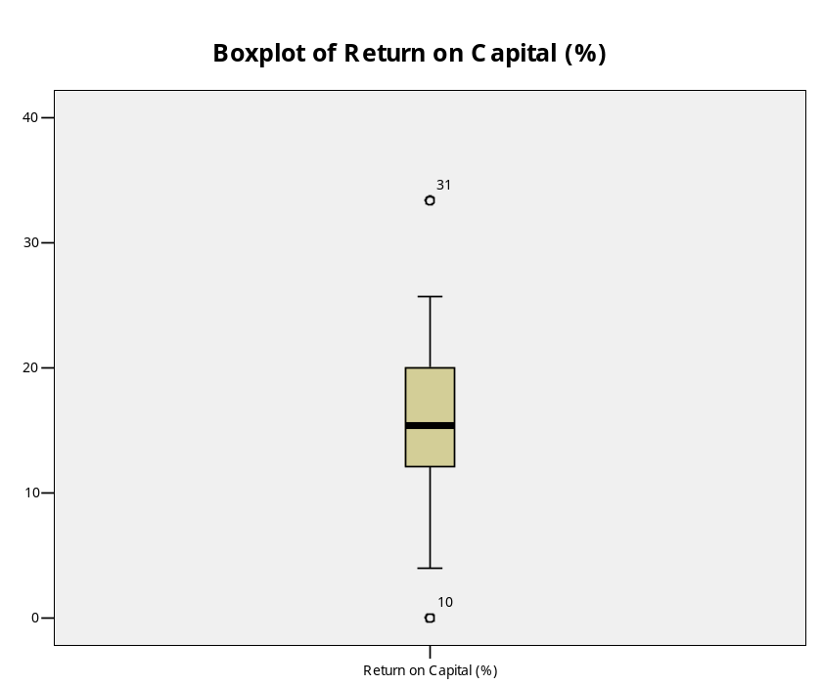
Solution to b
According the box-and-whiskers display, the return percentages have a median of 15.40.
The distribution is reasonably symmetric with two mild outlier.
2.54



某投资者2008年初以95元价格买入一张面值为100元，4年后到期的附息债券，如果息票利率为8%，每年末付息，则该项投资的到期收益率为？

